# Assignment -1 Arduino Uno Programming

|  |  |
| --- | --- |
| Assignment Date | 15 September 2022 |
| Student Name | K.Vinmathi |
| Student Roll Number | 912419104039 |
| Maximum Marks | 2 Marks |

To create circuit with Piezo alarm,PIR sensor,Temperature sensor with the following functionalities:

# Question-1:

ALARM SHOULD SOUND WITH ANOTHER FREQUENCY IF MOTION IS DETECED IN PIR SENSOR

void setup()

{

Serial.begin(9600); pinMode(5,OUTPUT);

}

void loop()

{

int data=analogRead(A0); double n=data/1024; double volt=n*6;

double off=volt-0.6;

double temperature=off*100; Serial.print("Temperature data:"); Serial.println(temperature); tone(5,100);

delay(1000); tone(5,200); delay(1000);

}

SCREENSHOT:

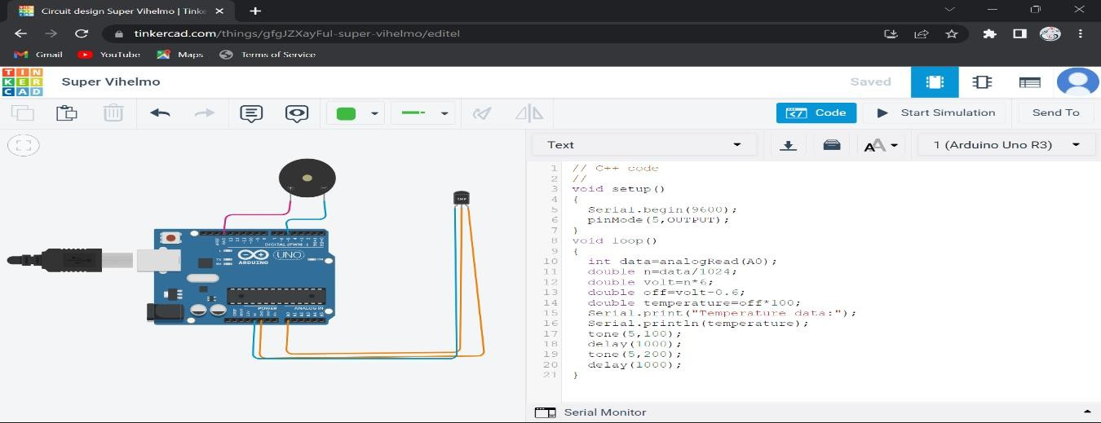

# Question-2:

ALARM SHOULD SOUND IN ONE MANNER IF TEMP IS ABOVE 60 C

void setup()

{

pinMode(2,INPUT); pinMode(13,OUTPUT);

}

void loop()

{

if(digitalRead(2)==HIGH)

{

digitalWrite(13,HIGH);

}

else

{

digitalWrite(13,LOW);

}

delay(10); // Wait for 1000 millisecond(s)

}

SCREENSHOT:

